**MADURAI KAMARAJ UNIVERSITY, MADURAI-02**

**Political Juggernauts: A Quantitative Analysis Of Candidates In The 2019 Lok Sabha Elections**

***Introduction***

In “Political Juggernauts: A Quantitative Analysis of Candidates in the 2019 Lok Sabha Elections,” we delve into the data-driven exploration of candidates’ performances, shedding light on key trends, demographic influences, and electoral dynamics that shaped the political landscape during this critical period in Indian politics.

***Purpose***

The purpose of “Introduction to Political Juggernauts: A Quantitative Analysis of Candidates in the 2019 Lok Sabha Elections” is likely to provide readers with a foundational overview of the research. This section typically outlines the significance of the study, its objectives, and may preview key findings or methodologies used in the quantitative analysis.

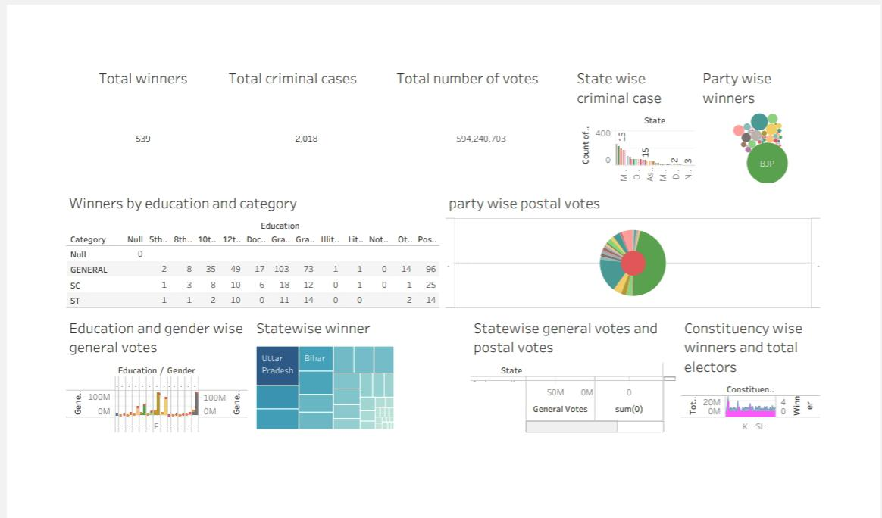***Dashboard 1***

 ***Result***

***Advantages and disadvantage***

1. **Name Recognition:** Established political juggernauts often enjoy widespread name recognition, which can positively influence voter trust and familiarity.
2. **Strong Party Backing:** Juggernauts usually have the backing of major political parties, providing them with extensive resources and a well-organized campaign infrastructure.
3. **Experience and Expertise:** Experienced candidates may bring a wealth of political knowledge and expertise to the table, potentially contributing to effective governance.

Disadvantages:

1. **Dynastic Politics:** Political juggernauts may be associated with dynastic politics, which can lead to concerns about nepotism and a lack of true meritocracy.
2. **Resistance to Change:** Established candidates might be less inclined to embrace innovative policies or reforms, potentially hindering progress.
3. **Limited New Perspectives:** Juggernauts might be less receptive to diverse voices and new ideas, limiting the representation of different viewpoints in governance.

Top of Form

Bottom of Form

***Application***

TABLEAU AND GITHUB used to apply the solution.

***Conclusion***

In conclusion, the 2019 Lok Sabha election presented a political juggernaut marked by diverse factors shaping the electoral landscape. From dynamic leadership to strategic alliances, voter sentiments played a pivotal role. The qualitative analysis underscores the intricate interplay of regional dynamics, socio-economic factors, and communication strategies. The election exemplified the evolving nature of Indian politics, reflecting a nuanced blend of tradition and modernity. As we reflect on this political saga, it becomes evident that the 2019 Lok Sabha election was not just a democratic exercise but a multifaceted political canvas reflecting the aspirations and complexities of a diverse nation.

***Future scope***

Analyzing the 2019 Lok Sabha election involves considering various factors such as regional dynamics, candidate selection, campaign strategies, and voter sentiment. The future scope for political juggernauts lies in adapting to evolving demographics, leveraging technology for targeted outreach, and addressing pressing socio-economic issues. Additionally, building alliances and fostering grassroots connections remain crucial for sustained political success.